




EDUPULSE: AI-DRIVEN REAL-TIME STUDENT FEEDBACK ANALYTICS FOR SMART LEARNING

Project Domain
Excel + Power BI + Copilot /AI Chat bot
A Project Report
Submitted in partial fulfilment of the requirements of the AICW Project

by:
Faculty Name
Dr.K.KARPAGAMBIGAI



Guide
Ms R.UMAMAHESWARI
Faculty Email
drkarpagambigaik@veltech.edu.in

Institution:
School of Commerce Veltech Rangarajan Dr.Sagunthala R&D Institute of Science and Technology
Year – 2026
ACKNOWLEDGEMENT

I would like to take this opportunity to express our deep sense of gratitude to all individuals who helped us directly or indirectly during this project work.
Firstly, I would like to thank my supervisor Ms.R.UmaMaheswari and Ms.Bharti Verma for being a great mentor and the best adviser we could have asked for. Their advice, encouragement, and constructive feedback served as a source of innovative ideas and inspiration, and were central to the successful completion of this project. Their continuous guidance, valuable suggestions, and constructive feedback throughout the project. Their support and encouragement played a crucial role in shaping this Project work.
I extend my sincere thanks to the Edunet Foundation, Microsoft, LinkedIn, and SAP for providing this fellowship opportunity, the learning resources, the platform to develop and showcase my AI skills and exposure to AI and data analytics tools.
I am deeply grateful to the respected Dean and Head of the Department of School of Commerce, Veltech Rangarajan Dr.Sagunthala R& D Insti itute of Science and Technology for providing the necessary infrastructure, academic environment, and support required to carry out this project effectively.
My sincere thanks to all the students who contributed their feedback, which served as the primary data source for this analysis. Finally, I thank my family members and friends for their continuous encouragement and support.

ABSTRACT OF THE PROJECT

This project is part of the AICW (Artificial Intelligence in the Contemporary World) Fellowship Program, a collaborative initiative by Edunet Foundation in partnership with Microsoft, LinkedIn, and SAP. The fellowship is designed to equip students with practical, hands-on skills in Artificial Intelligence, Data Analytics, and Business Intelligence tools.
This project focuses on the application of data analytics and artificial intelligence tools to evaluate student feedback for the Cost Accounting course across B.Com specializations. The dataset consists of 480 student responses collected under multiple themes, including syllabus coverage, communication, assessment, engagement, growth opportunities, and employability skills. The raw dataset contained inconsistencies such as missing values, duplicate records, and invalid Likert scale responses, necessitating systematic data preprocessing.
The objectives of the study were to structure and clean the dataset, analyze faculty performance and course effectiveness using quantitative techniques, develop interactive dashboards using Microsoft Excel and Power BI, and integrate AI tools such as Microsoft Copilot and chatbot systems for automated insight generation. The study also aimed to identify key performance indicators and highlight areas requiring improvement in teaching and learning processes.
The results of the analysis revealed that communication and teaching methodology significantly influence overall student satisfaction, while engagement and assessment practices vary across specializations. Faculty performance evaluation indicated measurable differences in effectiveness, and the dashboard visualizations provided clear insights into strengths and weaknesses across themes. The use of AI tools enhanced the speed and accuracy of analysis, enabling efficient identification of trends and patterns.
The project concludes that the integration of business intelligence tools and AI-driven analytics can significantly improve the evaluation of academic performance and support data-driven decision-making in educational institutions. The approach demonstrates a scalable and efficient framework for enhancing teaching quality and student learning outcomes.
TABLE OF CONTENTS

ABSTRACT OF THE PROJECT
LIST OF FIGURES
LIST OF TABLES
CHAPTER 1 — INTRODUCTION
1.1 Problem Statement
1.2 Motivation
1.3 Objectives
1.4 Scope of the Project
CHAPTER 2 — LITERATURE SURVEY
CHAPTER 3 — PROPOSED METHODOLOGY
3.1 System Design
3.2 Modules / Components Used
3.3 Data Flow Diagram (DFD)
3.4 Advantages
3.5 Requirement Specification
CHAPTER 4 — IMPLEMENTATION AND RESULTS
4.1 Data Cleaning Results
4.2 Visualization / Output Results
4.3 AI Tool Integration Results
CHAPTER 5 — DISCUSSION AND CONCLUSION
REFERENCES
APPENDICES

LIST OF FIGURES

Figure No. | Figure Title / Description | Page No.
Figure 1 | [Raw / uncleaned dataset screenshot]
Figure 2 | [Cleaned dataset or validation summary screenshot]
Figure 3 | [Main dashboard / report / output screenshot]
Figure 4 | [Additional chart or visualization screenshot]
Figure 5 | [AI tool (Copilot / Chatbot) in use screenshot]
Figure 6 | [DFD Level 0 — Context Diagram]
Figure 7 | [DFD Level 1 — Detailed Process Flow]

LIST OF TABLES

Table No. | Table Title / Description | Page No.
Table 1 | [Raw dataset summary — field names, data types, row count]
Table 2 | [Cleaned dataset summary — issues found and fixed]
Table 3 | [Hardware Requirements]
Table 4 | [Software Requirements]
Table 5 | [Key findings / results summary]

CHAPTER 1
INTRODUCTION
The rapid advancement of data analytics and artificial intelligence has significantly transformed decision-making processes across various sectors, including education. In higher education institutions, student feedback serves as a critical tool for evaluating teaching effectiveness, course design, and overall learning outcomes. However, traditional methods of analyzing feedback are often manual, time-consuming, and lack the ability to generate actionable insights.
This project, titled “Student Feedback Analytics for Smart Learning in Cost Accounting (B.Com)”, focuses on leveraging data analytics and AI-enabled tools to systematically evaluate student feedback. The study is based on a structured dataset collected from 480 students across different B.Com specializations, including General, Accounting & Finance, Computer Applications, and Corporate Secretaryship. The feedback is categorized under key themes such as syllabus coverage, communication and methodology, assessment and feedback, growth opportunities, teaching support, and employability skills.
The primary challenge addressed in this project is the presence of unstructured and inconsistent data, which limits the effectiveness of traditional evaluation methods. By applying data cleaning techniques and analytical tools such as Microsoft Excel and Power BI, the project transforms raw feedback into meaningful insights. Furthermore, the integration of AI tools, including Microsoft Copilot and chatbot systems, enhances the analytical process by automating data interpretation and generating intelligent summaries.
The project adopts a business analytics approach to evaluate faculty performance, identify strengths and weaknesses in course delivery, and highlight areas requiring improvement. Interactive dashboards are developed to visualize key performance indicators, enabling stakeholders to make informed decisions based on data-driven evidence.
Overall, this project demonstrates how modern data analytics and AI technologies can be effectively applied in the academic domain to improve teaching quality, enhance student learning experiences, and support continuous institutional development.
1.1 Problem Statement
Educational institutions routinely collect student feedback to evaluate teaching effectiveness and course quality. However, in the context of the Cost Accounting course offered across B.Com specializations, the feedback data is often underutilized due to several operational and analytical limitations.
The primary issue lies in the lack of a structured and systematic approach to process and analyze student feedback. The collected data is typically raw, containing inconsistencies such as missing values, duplicate entries, and invalid responses, which reduces its reliability for decision-making. Additionally, traditional methods of analysis rely heavily on manual interpretation, making the process time-consuming, error-prone, and inefficient.
Another critical challenge is the absence of integrated analytical tools and visualization mechanisms. Without the use of business intelligence tools, institutions are unable to effectively identify patterns, compare faculty performance, or evaluate key dimensions such as communication, engagement, and assessment practices. As a result, actionable insights that could improve teaching quality and student learning outcomes remain largely unexplored.
Furthermore, there adoption is limited of AI-driven tools such as Microsoft Copilot and chatbot systems in academic feedback analysis. This restricts the ability to automate insight generation, detect trends, and support data-driven decision-making.
Therefore, the core problem addressed in this project is the need to transform raw and unstructured student feedback data into meaningful, accurate, and actionable insights using data cleaning techniques, business intelligence tools, and AI-based analytics. This will enable effective evaluation of faculty performance, identification of improvement areas, and enhancement of the overall teaching–learning process in Cost Accounting for B.Com students.

1.2 Motivation
The selection of this project is driven by the growing importance of data-driven decision-making in education and the need to enhance teaching effectiveness through systematic analysis of student feedback. In the academic environment, especially in commerce and accounting disciplines, evaluating course delivery and learning outcomes is essential for maintaining quality standards. This project provides an opportunity to apply analytical and technological tools to address these practical challenges. Personal and Professional Significance
- The project is professionally relevant as it integrates accounting education with data analytics and business intelligence tools, which are highly valued in the fields of finance and commerce.
- It enhances practical skills in data preprocessing, visualization, and AI-assisted analysis, which are essential competencies in modern business environments.
- It provides exposure to tools such as Microsoft Excel, Power BI, and AI-based systems, thereby strengthening analytical and technical capabilities.
Real-World Applications
- Educational institutions can use this model to evaluate faculty performance and course effectiveness.
- Helps in curriculum improvement and academic planning based on data insights.
- Can be extended to other domains such as employee feedback analysis, customer satisfaction studies, and service quality assessment.
- Supports the development of automated reporting systems for institutional decision-making.
Impact on Organization
- Enables institutions to adopt a structured and transparent feedback evaluation system.
- Improves the quality of teaching by identifying strengths and areas for improvement.
- Facilitates evidence-based decision-making in academic administration.
- Enhances student satisfaction and learning outcomes through continuous improvement mechanisms.
Alignment with Modern Industry Trends
- The project aligns with the increasing adoption of Artificial Intelligence and Business Intelligence tools in data analysis.
- Reflects the trend of integrating AI-assisted analytics -Copilot, chat bots into routine data processing tasks.
- Supports the shift towards automation, real-time dashboards, and predictive insights in organizational decision-making.
This project is therefore motivated by its strong academic relevance, practical applicability, and alignment with current technological advancements in AI and data analytics.

  - Objectives
- To evaluate student feedback systematically across B.Com specializations for the Cost Accounting course using structured data analytics techniques.
- To identify key performance indicators (KPIs) related to teaching effectiveness, including syllabus coverage, communication, assessment, and student engagement.
- To preprocess and standardize raw feedback data by addressing inconsistencies such as missing values, duplicate records, and invalid responses.
- To analyze faculty performance based on quantitative feedback and compare effectiveness across different specializations.
- To assess the impact of teaching methodologies on student satisfaction and learning outcomes.
- To develop interactive dashboards using Microsoft Excel and Power BI for clear visualization of insights.
- To integrate AI tools -Microsoft Copilot and chatbot systems for automated data analysis, insight generation, and reporting.
- To identify critical improvement areas in course delivery, assessment methods, and student support systems.
- To support data-driven decision-making for academic planning and quality enhancement in higher education.
- To demonstrate the application of business intelligence and AI tools in educational analytics within the accounting domain
1.4 Scope of the Project
- Dataset Coverage:
This project covers student feedback data collected from 480 B.Com students across four specializations—General, Accounting & Finance, Computer Applications, and Corporate Secretaryship. The dataset includes responses measured using a Likert scale across multiple themes such as syllabus coverage, communication, assessment, engagement, growth opportunities, teaching support, and employability skills.
- Tools Used:
The tools used in this project are limited to Microsoft Excel, Microsoft Power BI, Microsoft Copilot, and AI Chatbot systems for data cleaning, analysis, visualization, and AI-assisted insight generation.
- Focus of Analysis:
The project focuses on data preprocessing (handling missing values, duplicates, and invalid entries), statistical analysis, visualization through dashboards, and AI-assisted reporting. It emphasizes evaluating faculty performance and course effectiveness using structured feedback data.
- Out of Scope:
The project does not include real-time data integration, advanced machine learning or predictive modeling, large-scale database systems, or deployment of a live application environment.
- Project Nature:
This project is intended as an academic and fellowship-based demonstration of applying data analytics and AI tools in education. It is designed for learning and research purposes and is not a production-level or enterprise implementation.

CHAPTER 2
LITERATURE SURVEY.
Research in the domain of student feedback analytics and learning analytics emphasizes the use of data to improve teaching effectiveness, student engagement, and academic performance. Studies indicate that feedback plays a crucial role in enhancing learning outcomes, and integrating analytics enables timely, personalized, and actionable feedback mechanisms
LEARNING ANALYTICS & LEARNING DESIGN
- KATERINA MANGAROSKA &MICHAIL GIANNAKOS
The study highlighted that it enables a shift from traditional teaching methods to personalized and adaptive learning systems. Institutions increasingly use analytics to monitor student performance Improve retention rates and Support academic decision-making. Visualization dashboards are the most widely used tools. Learning analytics improves quality and timeliness of feedback and it supports self-regulated learning and student engagement.
STUDENT FEEDBACK & PEER ASSESSMENT ANALYTICS
-JOHN HATTIE & HELEN TIMPERLEY
Highlighted importance of formative assessment and feedback effectiveness Analytical techniques such as: Clustering Predictive analytics Feedback classification were applied. Automated classification of feedback improves efficiency Predictive models help identify student learning gaps. The visualization aids instructors in focusing on critical feedback areas
EDUCATION AND PEDAGOGY –HATTIE& WILIAM
The Study has significantly influenced the understanding of student feedback and assessment practices..Hattie’s meta-analytical studies highlight that effective feedback helps learners understand their current performance, identify gaps, and take steps for improvement. Similarly, Wiliam’s research on formative assessment underscores the importance of continuous feedback in enhancing classroom learning and student engagement. Both scholars advocate for feedback systems that promote self-regulated learning, where students actively reflect on their progress and take responsibility for their learning outcomes. However, traditional feedback mechanisms are often limited by delayed responses and lack of personalization.
2.2 Tools and Technologies Review
- Microsoft Excel
Microsoft Excel is widely used for data cleaning, transformation, and preliminary analysis. In this project, it is applied for handling missing values, removing duplicates, and standardizing Likert scale responses. Advanced features such as pivot tables, conditional formatting, data validation, and basic statistical functions are used to summarize and organize the dataset efficiently.
- Microsoft Power BI
Microsoft Power BI is employed for developing interactive dashboards and visualizations. It enables the transformation of processed data into meaningful insights through charts, graphs, and reports. Its user-friendly interface allows for the creation of dynamic dashboards that facilitate comparison of faculty performance, course effectiveness, and theme-wise analysis.
- Microsoft Copilot
Microsoft Copilot serves as an AI-powered assistant integrated within Microsoft 365 applications. It is used to automate data analysis tasks, generate summaries, and provide insights using natural language prompts. Copilot enhances productivity by reducing manual effort and enabling quick interpretation of complex datasets.
- AI chat bots
AI chat bots are utilized for generating analytical insights, summarizing findings, and assisting in report preparation. These tools support prompt-based interaction, allowing users to query the dataset and obtain instant, structured responses. They improve efficiency in documentation and interpretation of results.
- Microsoft Power Query
Power Query is used within Excel and Power BI for advanced data transformation and automation of data cleaning processes. It enables efficient handling of large datasets by performing tasks such as filtering, merging, and reshaping data, thereby improving data quality and consistency. Overall, the integration of these tools provides a comprehensive framework for data preprocessing, visualization, and AI-assisted analytics, ensuring accurate and efficient evaluation of student feedback in the Cost Accounting course.
2.3 Gaps Identified
- Lack of Structured Feedback Datasets:
Many studies rely on unstructured or limited datasets, with insufficient emphasis on well-organized, theme-based feedback data suitable for systematic analysis.
- Overdependence on Complex Models:
Existing research frequently uses advanced machine learning and statistical models, which are not easily accessible or implementable by non-technical academic users.
- Limited Practical Implementation:
There is a gap between theoretical research and practical application, particularly in using simple tools like Excel and Power BI for real-world academic feedback analysis.
- Insufficient Integration of AI Tools:
Minimal research is available on integrating AI tools such as Microsoft Copilot and AI chatbots with traditional data analysis platforms for educational feedback systems.
- Data Quality Issues Not Addressed:
Many studies do not adequately focus on pr processing challenges such as missing values, duplicates, and inconsistent Likert scale responses.
- Lack of Real-Time and Automated Insights:
Traditional feedback systems lack automation and do not provide real-time or prompt-based analytical insights for decision-making.
- Limited Focus on Faculty Performance Evaluation:
Existing literature emphasizes student performance more than structured evaluation of faculty teaching effectiveness using feedback data.
- Inadequate Visualization Techniques:
Many approaches fail to utilize interactive dashboards and business intelligence tools for clear and user-friendly representation of insights.
- Absence of Standardized Analytical Framework:
There is no widely accepted framework combining data cleaning, analysis, visualization, and AI integration specifically for student feedback analytics.
- Restricted Domain-Specific Applications:
Limited studies focus specifically on commerce and accounting education, such as Cost Accounting, creating a gap in domain-specific analytical models.
CHAPTER 3
PROPOSED METHODOLOGY
3.1 SYSTEM DESIGN
The system design of this project follows a structured data analytics framework, where raw student feedback data is transformed into meaningful insights through systematic stages of data processing, analysis, and visualization. The overall design ensures a smooth flow of data from input to output, enabling effective evaluation of teaching and learning outcomes.
- Data Source / Input
The raw dataset comprises responses collected from students for the Cost Accounting course. The dataset is organized in tabular format combining students real time responses and data set source from kaggle. This raw dataset forms the foundation for computing composite indices, performing comparative analysis across faculty, and generating interactive dashboards for academic performance evaluation.
Table-1-Raw data set summary-Edu Pulse-Student Feedback on Smart Learning
Course | Bachelor of Commerce
Specialization | B.Com General  B.Com Accounting & Finance  B.Com Computer Applications  B.Com Corporate Secretaryship
Subject | Cost Accounting
Faculty Name | Prof. Meena, Prof. Kumar, Prof. Seetha, Prof. Suresh
Total Student Responses | 500
Actual Responses | 480
Feedback Variables | Syllabus Coverage and Preparation, Communication and Methodology, Assessment and Feedback, Growth and Opportunities, Teaching Support and Engagement Skills and Employability
Analytics | Likert Scale  Rating Scores

The Structured data source for this project is a student feedback dataset collected from 480 B.Com students enrolled in the Cost Accounting course across four specializations:
- B.Com General (A & B)
- B.Com Accounting & Finance (A & B)
- B.Com Computer Applications (A & B)
- B.Com Corporate Secretaryship (A & B)
The dataset is stored in Excel (.xlsx) format and consists of:
- Student identifiers and course details
- Faculty information -4 faculty members handling different specializations
Table-2-Cleaned data set summary-Edu Pulse-Student Feedback on Smart Learning
Faculty Name | B.Com-Specialization | Total Students Enrolled
Prof. Meena | B.Com-General | 120
Prof. Kumar | B.Com-Corporate Secretary ship | 120
Prof. Seetha | B.Com-Accounting and Finance | 120
Prof. Suresh | B.Com-Computer Application | 120
 | Total Responses | 480

Primary Feedback Variables-Theme-based Feedback Variables
  - Syllabus Coverage and Preparation -SC
  - Communication and Methodology -CM
  - Assessment and Feedback -AF
  - Growth and Opportunities -GO
  - Teaching Support and Engagement -TE
  - Skills and Employability –SE
Secondary Feedback Variables- Subthemes-based Feedback Variables
Theme based Feedback Variables  (Primary Feedback Variables) | Subthemes based Feedback Variables  (Secondary Feedback Variables)
Syllabus Coverage and Preparation (SC) | SC_Q1: Defined Syllabus clarity  SC_Q2: Planned Schedule adherence  SC_Q3: Adequate Topic explanation  SC_Q4: Sufficient Lecture preparation  SC_Q5: Structured learning Framework
Communication and Methodology (CM) | CM_Q1: Concepts clarity  CM_Q2: Appropriate Teaching Method  CM_Q3: Real time Examples and Illustrations  CM_Q4: Good Teaching Pace  CM_Q5: Immediate Query Resolution
Assessment and Feedback (AF) | AF_Q1: Regular Assessment  AF_Q2: Exam Oriented Revision  AF_Q3: Timely Feedback  AF_Q4: Monitor Performance Status  AF_Q5: Evaluation Transparency
Growth and Opportunities (GO) | GO_Q1: Analytical Skills  GO_Q2: Practical Application  GO_Q3: Academic Growth  GO_Q4: Student Participation  GO_Q5: Career Growth
Teaching Support and Engagement (TE) | TE_Q1: Academic Support  TE_Q2: Study Material Quality  TE_Q3: Digital tools Usage  TE_Q4: Class Engagement  TE_Q5: Student Motivation
Skills and Employability (SE) | SE_Q1: Practical Skills  SE_Q2: Industry Relevance  SE_Q3: Decision Making  SE_Q4: Employment Utility  SE_Q5: Professional Foundation

Key Performance Variables:
Key Performance Variables | Subthemes based Feedback Variables
Student Feedback Perception  About the Faculty and Course | SF_Q1: Teaching Quality Satisfaction  SF_Q2: Learning Expectations  SF_Q3: Faculty Recommendation Score  SF_Q4: Learning Growth Environment  SF_Q5: Course Recommendation Score
Improvement Area Indicators | IA_Q1: Practical Exposure  IA_Q2: Resource adequacy  IA_Q3: Revision Support  IA_Q4: Teaching Enhancement  IA_Q5: Applied Assessment

Faculty Overall Rating-Performance Metrics
Overall Rating: Rate the overall performance of the faculty.
(1 – Poor | 2 – Fair | 3 – Good | 4 – Very Good | 5 – Excellent)

Likert Scale:
1 – Strongly Disagree | 2 – Disagree | 3 – Neutral | 4 – Agree | 5 – Strongly Agree

The Analysis employs a 5-point Likert scale ranging from 1 (Strongly Disagree) to 5 (Strongly Agree) to quantify student perceptions regarding subject delivery and faculty performance in Cost Accounting. Each response is assigned a numerical weight, enabling the transformation of qualitative opinions into measurable data. The collected responses are aggregated to compute Average scores, satisfaction indices, and comparative performance metrics across different dimensions such as syllabus coverage, teaching effectiveness, assessment, and employability. Higher Average scores indicate stronger agreement and higher satisfaction levels, while lower scores highlight areas requiring improvement. This scaling technique facilitates benchmarking, and dashboard visualization, thereby supporting objective evaluation and data-driven academic decision-making.

- Data Cleaning

Removed Duplicates
- Checked for repeated Student_ID entries.
- Ensured each row represented a unique student response.
- Dropped any exact duplicates to maintain data integrity.
Handled Null or Missing Values
- Scanned all columns for blanks or missing entries.
- For numerical feedback questions named SE_Q1 to SE_Q5, replaced missing values with the Average score of that question to preserve statistical balance.
Standardized Formats
- Unified rating scales to a consistent 1–5 range.
- Trimmed extra spaces and corrected inconsistent naming.
- Ensured column headers were clean and descriptive for dashboard mapping
- Analysis & Processing Techniques

1. Excel-Based Analysis
- Pivot Tables:
  - Created pivot tables to summarize average scores per faculty, course, Theme based and sub theme based feedback variable
  - Used Filters to compare Performance across Faculty members
- Formulas Used:
  - AVERAGEIFS to calculate theme-wise scores by faculty/course.
  - COUNTIFS to track rating distributions- how many students gave a score of 5

2. Power BI Dashboard
- Data Model Setup:
  - Imported cleaned Excel data into Power BI.
  - Created relationships between Student_ID, Course, and Faculty for dynamic filtering.
- Measures Created:
Teaching Quality
Teaching_Quality = DIVIDE( ’Table’[SC_Avg] + ’Table’[CM_Avg] + ’Table’[AF_Avg], 3 ) Learning Outcome
Learning_Outcome = DIVIDE( ’Table’[GO_Avg] + ’Table’[SE_Avg], 2 )
Student Experience
Student_Experience = DIVIDE( ’Table’[TE_Avg] + ’Table’[SF_Avg], 2 )
3. AI Prompting & Insight Extraction- Prompt Design Structure
- Descriptive Analysis Prompts-“Summarize the overall student satisfaction levels across all faculties.”
- B. Comparative Analysis Prompts-“Compare Teaching Excellence Scores across faculties - highlight performance gaps.”
- C. Diagnostic Insight Prompts- “Analyze which dimension -SC, AF, TE, SE, GO. CM has the lowest aveage score.
- D. Predictive / Prescriptive Prompts-“Suggest improvement strategies for faculties with lower satisfaction scores.”
- Visualization and Output
Faculty-wise performance comparison Course-wise satisfaction levels Theme-wise analysis give dashboard visualizations with insights. The structured dashboard-style analysis of the Cost Accounting Feedback Dataset with faculty-wise, course-wise, and theme-wise insights.
Dash Board Components
- Syllabus coverage and Preparation Pulse
- Communication and Teaching Methodology Pulse
- Assessment and Feedback-performance Matrix
- Teaching Excellence Analytics
- Student Feedback Analytics
- Faculty Performance-Leader Board
- Teaching Learning Outcomes
- Faculty Rating Validation

Theme-wise Analysis

The Syllabus coverage and preparation pulse of the faculty members reflects stable performance with moderate satisfaction levels, indicating the need to shift neutral and average responses toward higher satisfaction through improved teaching methods, engagement, and feedback mechanisms. Among the Four faculty members Prof. Meena and Prof. .Kumar scores First and Second position position among the B,Com-General and B.Com-CS Students.

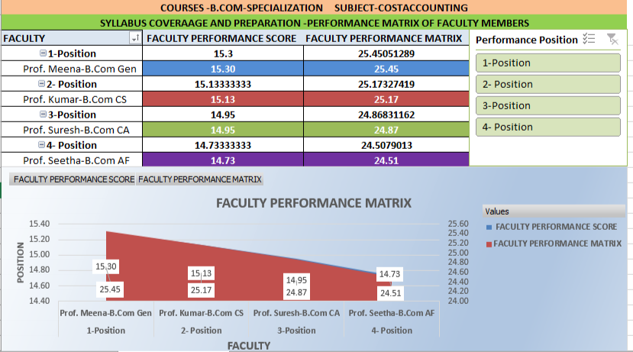

Dashboard Visualization and Insights
- Clustered Column Chart – Average ratings across SE, SC, CM, AF, GO for all four faculties
- Line or Area chart – Assessment and Feedback Pulse Analytics of the faculty members.
- Improvement Trend Line – Plot Improvement line for the priority areas of improvement
- Bar graph-Faculty performance Matrix for communication and teaching methodology.
- Overall Rating Distribution Pie Chart – Show proportion of students rating faculty 1–5.
- Scatter Chart –Teaching and learning Outcomes of the Faculty Members
- Stacked Area Chart- Faculty Rating Validation.

3.2 MODULES / COMPONENTS USED

MODULE 1 — DATA INGESTION
- Imported the raw dataset into Excel for initial review.
- Loaded into Power BI for dynamic analysis and visualization.
- Ensured column headers and data types were preserved during import.
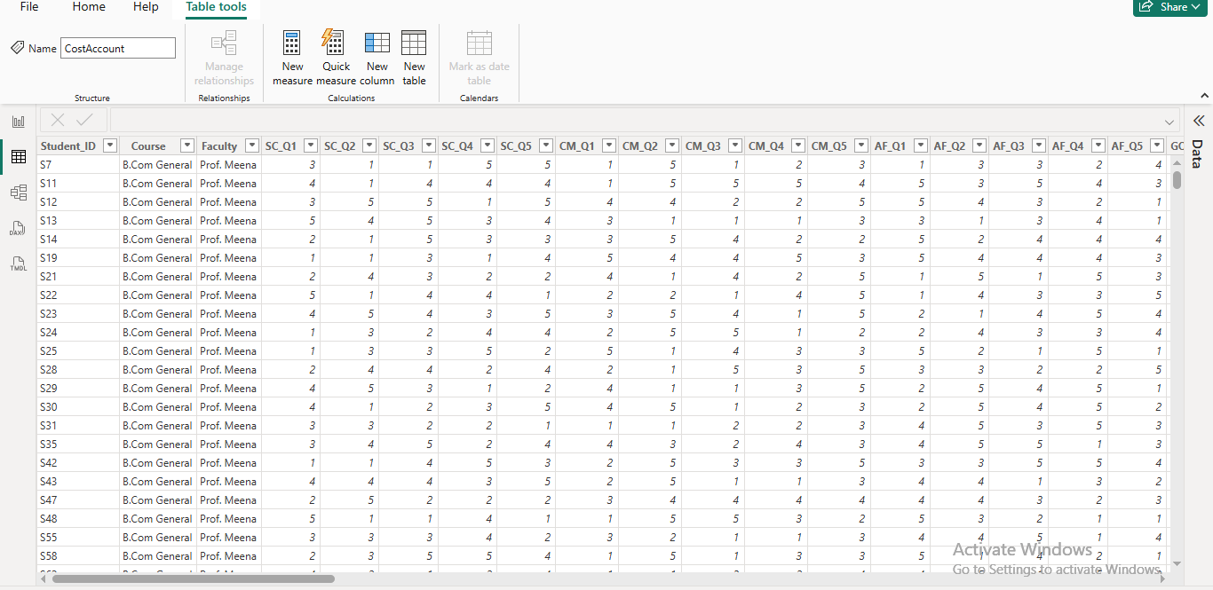

MODULE 2 DATA CLEANING IN POWER BI AND EXCEL
- Removed duplicate Student_ID entries in Microsoft Excel
- Load the Data Open Power BI Desktop.
- Click on Home in the top ribbon
- Click Get Data
- Choose Excel or Text/CSV
- Select dataset and click Load
- Click Transform Data
- In Power Query Editor- Check that all Sub themes Feedback Variables columns such as SC Q1, CM Q1, etc. are of type Whole Number
- Ensure column names are clean and consistent
- Replace values and Errors
- Add Additional Columns in creating Average of SC,CM,AF,GO, TE, SE(Q1-Q5)
- Click Close & Apply
- Create Measures in Power BI

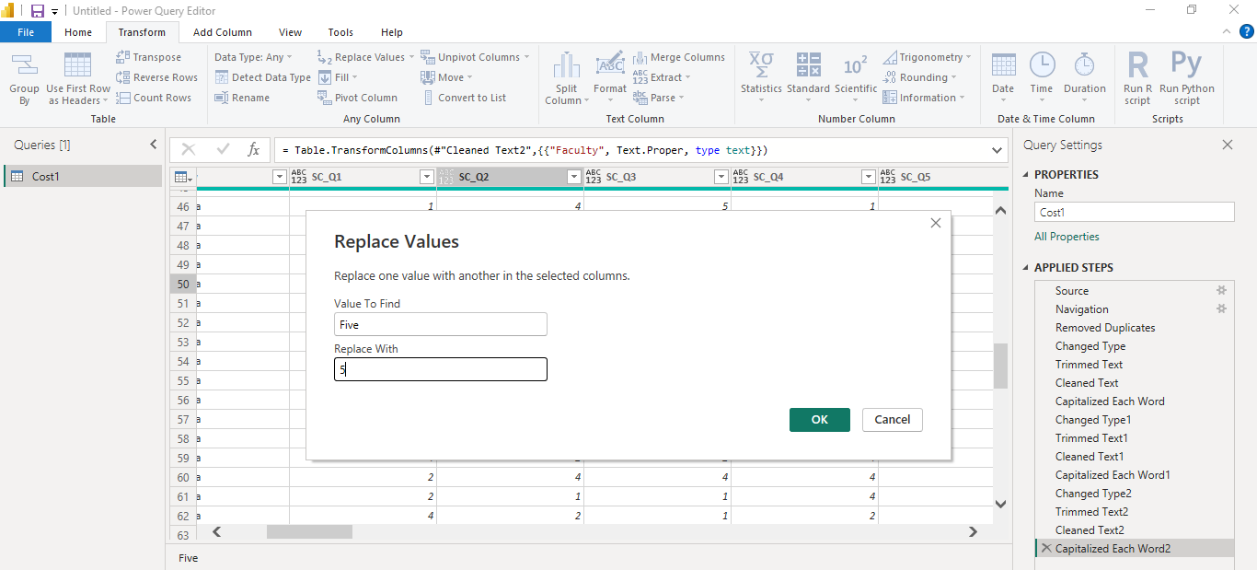

MODULE 3 — DATA ANALYSIS
- Used Excel formulas like AVERAGEIFS, SUM, PERCENTAGE Calculation =SUM(B4:F4)
=AVERAGE (SQ_Q1: SQ_Q5)
- In Power BI the formula like
SC Average SC_Avg = DIVIDE( ’Costsheet’[SC_Q1] + ’Costsheet’[SC_Q2] + ’Costsheet’[SC_Q3] + ’Costsheet’[SC_Q4] + ’Costsheet’[SC_Q5], 5 )
Repeat the same process for: CM Avg using CM Q1 to CM Q5 ,AF Avg using AF Q1 to AF Q5 , GO Avg using GO Q1 to GO Q5, TE Avg using TE Q1 to TE Q5, SE Avg using SE Q1 to SE Q5, SF Avg using Student Feedback Q1 to Q5, IA Avg using Improvement Q1 to Q5
- Applied AI prompts to extract insights and summarize feedback themes.

MODULE 4 — VISUALIZATION / REPORT GENERATION
Line or Area chart – Assessment and Feedback Pulse Analytics of the faculty members.
Bar Graph –Teaching Performance Spectrum-Comparative Analytics
Stacked Area Chart – Faculty Performance-Leader Board
KPI -Dashboards
• Teaching Quality
• Learning Outcome
• Student Experience
• Improvement Pressure
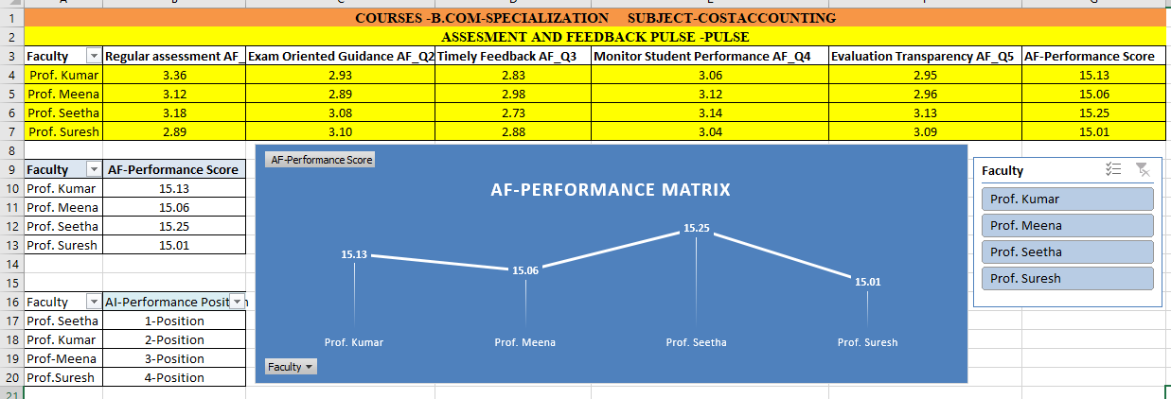

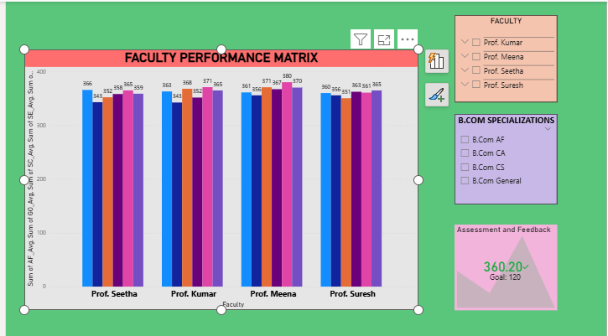

MODULE 5 — AI INTEGRATION
Used Copilot to:
- Summarize student feedback
- Generate insights from rating patterns
- Design dashboard visuals and layout
- Draft report narratives and presentation content
Used Chat bots
Performance Measurement Assistant

MODULE 6 — INSIGHT EXTRACTION & RECOMMENDATION
Teaching Excellence Comparative analytics
Dimension | Highest Performer | Insight
SC (Syllabus Coverage) | Prof. Meena (15.30) | Strong planning and delivery alignment
CM (Content Mastery) | Prof. Suresh (15.16) | Effective subject knowledge and clarity
AF (Assessment & Feedback) | Prof. Seetha (15.25) | Robust evaluation and feedback mechanisms
Recommendation
Introduce Faculty Benchmarking System
Develop Performance-Based Incentives
Conduct Periodic Teaching Audits
Implement Peer Learning & Mentoring Programs

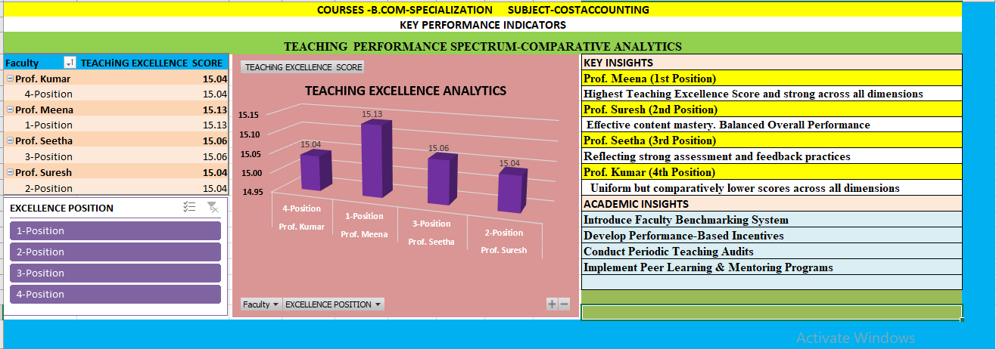
3.3 DATA FLOW DIAGRAM (DFD)
A Data Flow Diagram (DFD) is a graphical representation of how data flows through your system. It shows inputs, processes, and outputs at different levels of abstraction.

DFD Level 0 — Context Diagram-This diagram represents the entire system as a single process: Flow:
- Input: Raw Feedback Dataset (Excel file with student ratings and comments)
- Process: Feedback Analysis System
- Output: Cleaned Data → Dashboard Visuals → Insightful Reports

DFD Level 1 — Detailed Process Flow-This diagram breaks down the main process into four sub-processes:

Sub-process 1: Data Loading & Validation
- Load Excel dataset into Excel or Power BI.
- Validate column headers, data types, and completeness.
- Store in Raw Data Repository.

Sub-process 2: Data Cleaning & Transformation
- Remove duplicates, handle nulls, standardize formats.
- Convert ratings to numeric, categorize faculty/course.
- Store in Filtered Data Repository.

Sub-process 3: Analysis & AI Processing
- Apply formulas, pivot tables, and DAX measures.
- Use Copilot/AI to extract insights and summarize feedback.
- Store in Insights & Metrics Repository.

Sub-process 4: Visualization & Report Generation
- Build dashboards (bar charts, radar charts, pie charts).
- Generate infographic-style reports and summaries.
- Output to Dashboard Views and Report Files.
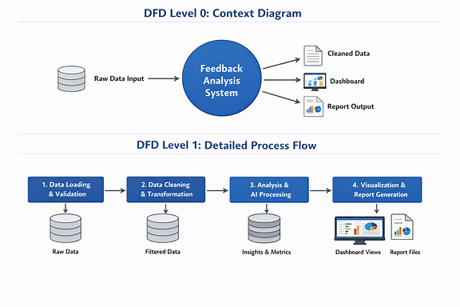
  - ADVANTAGES
Automated Data Cleaning-Reduces manual errors and ensures consistent formatting, Handles missing values, duplicates, and type mismatches efficiently.

Insightful Analysis with AI Support-Combines traditional formulas (Excel,)with AI-generated summaries, Extracts hidden patterns and recommends actionable improvements.

Interactive Dashboards-Power BI visuals offer dynamic filtering by faculty, course, and theme, Stakeholders can explore data intuitively without technical expertise.

Theme-Based Evaluation-Breaks feedback into meaningful categories (Engagement, Clarity, Materials, Feedback, Outcomes), Enables targeted interventions for each weak area.

Faculty & Course Comparison-Highlights performance gaps between instructors and courses, Supports data-driven decisions for training and curriculum design.

Student-Centric Reporting-Includes student feedback summaries and satisfaction scores, Promotes transparency and responsiveness in academic planning.

Reusability & Adaptability-The framework can be reused for other subjects, semesters, or institutions., Easily integrates with future datasets or survey formats.

3.5 REQUIREMENT SPECIFICATION
Hardware Requirements
Component | Specification
Processor | Intel Core i3 or higher (i5/i7 recommended)
RAM | Minimum 4 GB (8 GB recommended)
Storage | Minimum 50 GB free disk space
Display | 1366 x 768 resolution or higher
Internet | Required for Copilot / Chatbot access
Software Requirements
Software | Details
Operating System | Windows 10 / 11 or macOS
Microsoft Excel | Microsoft 365 (Excel with Copilot) / Excel 2019+
Power BI Desktop | Latest version (free download from Microsoft)
Microsoft Copilot | Integrated via Microsoft 365 subscription
AI Chatbot | ChatGPT / Google Gemini / Microsoft Copilot (web)
Web Browser | Google Chrome / Microsoft Edge (latest version)
CHAPTER 4
IMPLEMENTATION AND RESULTS
This chapter presents the actual implementation of the project and the results obtained at each stage. Screenshots of dashboards, cleaned datasets, or generated content should be inserted where indicated
4.1 DATA CLEANING RESULTS

Dataset Source-The dataset base was provided by Kaggle and integrated the feedback collection initiative from the students of our institution for Cost Accounting courses across B.Com General and B.Com AF streams and integrated both and framed Structured Data set.
Raw and Uncleaned dataset size: Number of rows -500 and columns in the raw data-44

Cleaned Dataset Size Number of rows -480 and columns in the raw data-44

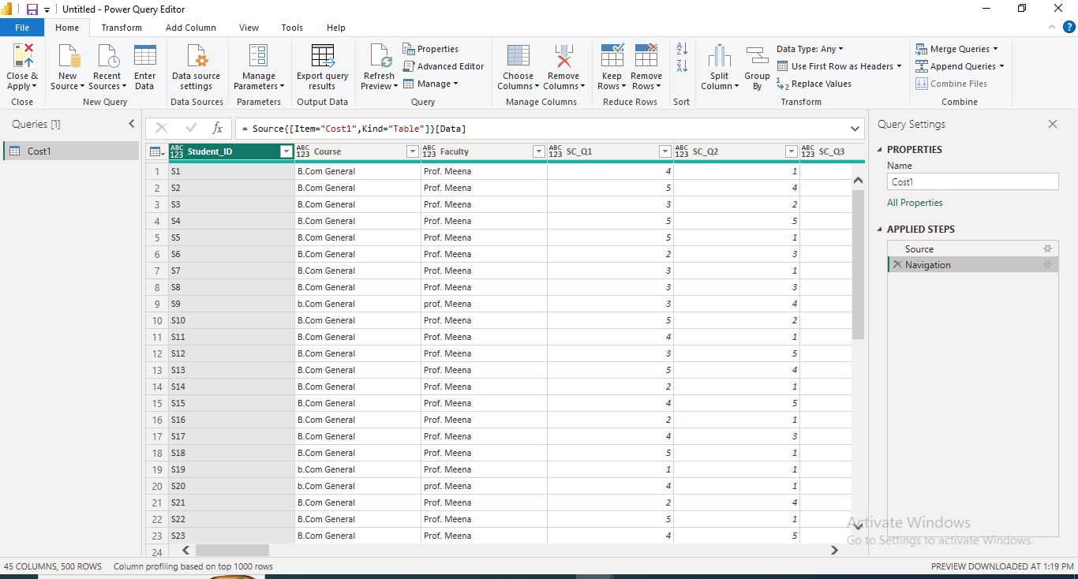
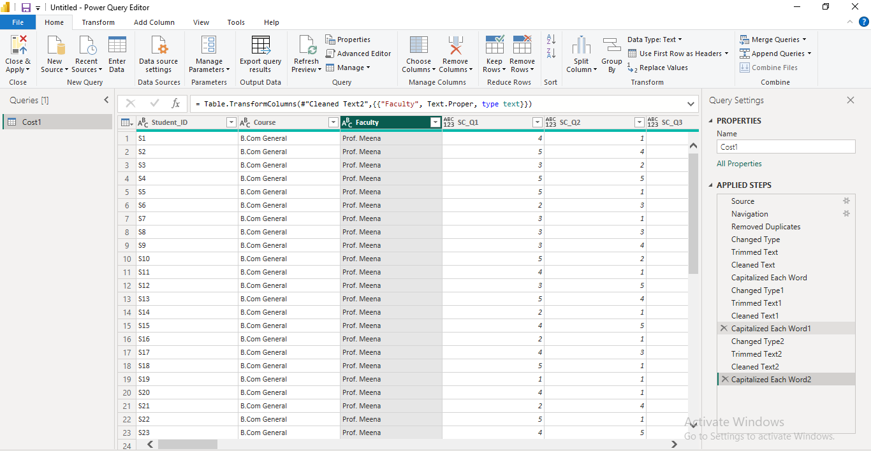
4.2 VISUALIZATION / OUTPUT RESULTS
Dashboard / Chart 1 — Faculty Teaching Quality Matrix

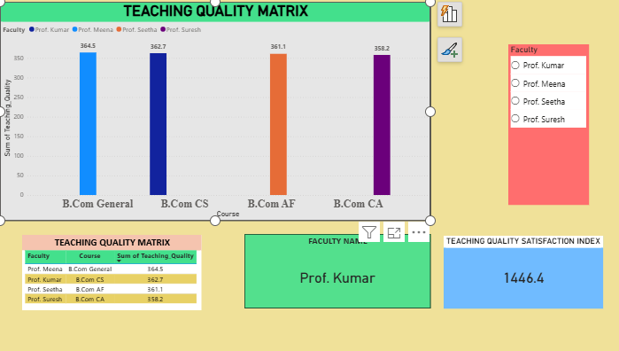

Dashboard / Chart 2 — Teaching Learning Outcomes
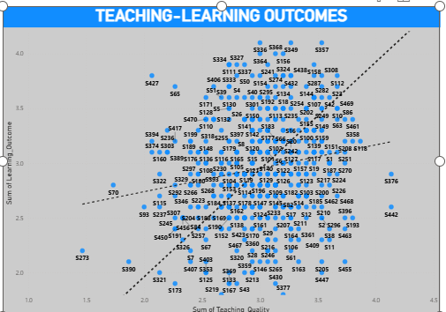
  - AI TOOL INTEGRATION RESULTS

Tool Used-Microsoft Copilot was used for data analysis, visualization design, and insights.

Prompts Used-Some of the key prompts applied during the project included:
- “Faculty-wise performance comparison, course-wise satisfaction levels, theme-wise analysis — give dashboard visualizations with insights.” → Produced comparative dashboards highlighting strengths and weaknesses of each faculty and course.
- “Give pie chart visuals for overall rating distribution.” → Generated clear pie charts showing how students rated faculty overall (1–5 scale).

Output Quality
- The AI-generated outputs were accurate and structured
- Dashboards and charts were visually clear, with consistent color coding and legends.
- Narrative summaries were concise yet insightful, making them suitable for reports and presentations.
- The outputs balanced technical details with insight summaries.
Project Enhancement
- Faster Analysis: Automated summarization of large datasets saved significant time compared to manual review.
- Better Insights: AI identified hidden patterns (e.g., weak performance in Assignments & Feedback across both courses).
- Professional Reporting: Generated polished dashboard visuals and structured report sections that could be directly used in academic or administrative presentations.
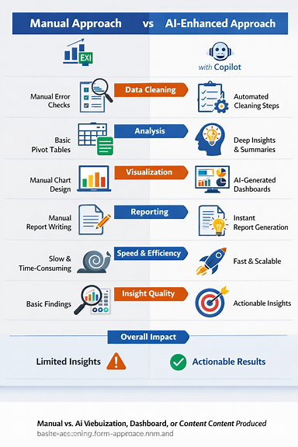
CHAPTER 5
DISCUSSION AND CONCLUSION
5.1 KEY FINDINGS
- Data Quality Enhancement
- AI Efficiency Gains- AI produced presentation-ready visuals and structured insights instantly.
- Faculty Performance Insights
- Prof. Meena showed high potential but inconsistent ratings across themes.
- Prof. Seetha maintained stable performance with fewer low scores, especially in Student Engagement and Course Material.

Course Satisfaction Patterns
- B.Com General had polarized feedback (highs and lows), indicating varied student experiences.

Weakest Theme Identified
- Assignments & Feedback (AF) emerged as the lowest-rated theme across both courses.
- Students consistently rated AF_Q1–AF_Q5 below 3, signaling a need for improved feedback mechanisms.
- B.Com AF showed more balanced satisfaction, with consistent 3–4 ratings across themes.

Rating Distribution
- Majority of students rated faculty 3 or 4, indicating moderate satisfaction.
- Only 15% gave a perfect score (5), while 30% rated below 3, highlighting areas for improvement.
5.2 PROJECT LINKS
- GitHub Link of the Project:
- Video Recording of Project Demonstration:
- Power BI / Dashboard Link
5.3 LIMITATIONS
The limitation of the current project is that it relies heavily on structured rating data without incorporating deeper qualitative feedback such as open-ended student comments or session-specific context, which could provide richer insights. Additionally, while AI tools like Copilot accelerated analysis and visualization, they depend on clean, well-labeled input—any ambiguity or inconsistency in the raw dataset can reduce output accuracy. The dashboard also focuses on averages and distributions, which may mask outliers or minority voices. Finally, the system is tailored to a specific course and faculty set, so broader generalization across departments or institutions would require further customization and validation.
5.4 FUTURE WORK
In the next phase, this project can be expanded by integrating qualitative feedback analysis (e.g., sentiment analysis of student comments) alongside quantitative ratings to capture richer insights. Incorporating predictive analytics in Power BI could help forecast satisfaction trends and identify at-risk themes before they decline. Another enhancement would be to connect the dashboard with real-time data sources (such as ongoing surveys or LMS platforms) so faculty and coordinators can monitor feedback continuously rather than at the end of a term. Additionally, building faculty development recommendation modules—where AI suggests targeted training or interventions based on weak areas—would make the system more actionable. Finally, scaling the framework across multiple departments or institutions, with customizable templates, would establish a standardized feedback ecosystem that supports broader educational innovation and student empowerment.
5.5 CONCLUSION
This project successfully transformed raw student feedback data into actionable insights through a structured pipeline of data ingestion, cleaning, analysis, visualization, and AI integration. By combining Excel formulas, Power BI dashboards, and Copilot’s AI-driven summaries, the system provided a clear picture of faculty performance, course satisfaction, and theme-specific strengths and weaknesses. The dashboards highlighted critical improvement areas—particularly in Assignments & Feedback—while also showcasing overall student satisfaction trends. AI integration significantly reduced analysis time, improved reporting quality, and delivered presentation-ready outputs. Although the current approach is limited by its reliance on structured ratings and course-specific scope, it establishes a strong foundation for future expansion into qualitative feedback analysis, predictive modeling, and institution-wide deployment. Ultimately, the project demonstrates how data-driven insights and AI support can empower educators to make informed decisions, enhance teaching effectiveness, and improve student learning experiences.
REFERENCES

List all references, research papers, tutorials, and documentation used in the project in the format below:
[1] Microsoft Corporation. Microsoft Excel Documentation. Available at: https://support.microsoft.com/en-us/excel
[2] Microsoft Corporation. Power BI Documentation. Available at: https://learn.microsoft.com/en-us/power-bi/
[3] Microsoft Corporation. Microsoft Copilot — AI-Powered Productivity. Available at: https://copilot.microsoft.com
[4] Edunet Foundation. AICW Fellowship Program Guidelines. 2026.
APPENDICES
Appendix A — Sample Dataset
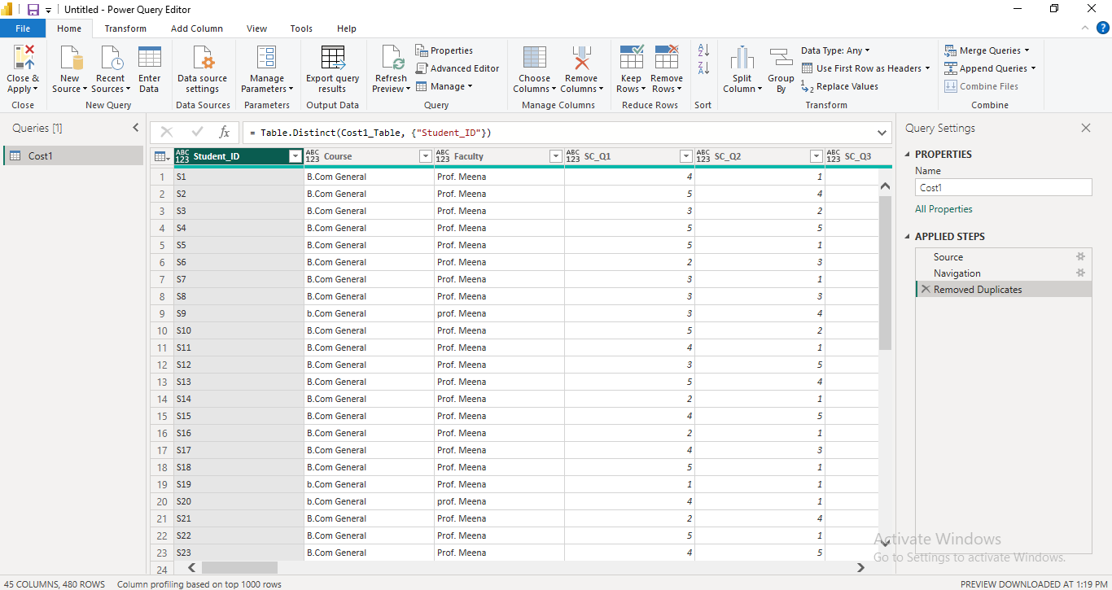
Appendix B — Key Excel Formulas / Measures Used
Teaching Quality
Teaching_Quality = DIVIDE( ’Table’[SC_Avg] + ’Table’[CM_Avg] + ’Table’[AF_Avg], 3 ) Learning Outcome
Learning_Outcome = DIVIDE( ’Table’[GO_Avg] + ’Table’[SE_Avg], 2 )
Student Experience
Student_Experience = DIVIDE( ’Table’[TE_Avg] + ’Table’[SF_Avg], 2 )

C — AI Prompts Used

Descriptive Analysis Prompts-“Summarize the overall student satisfaction levels across all faculties.”

Comparative Analysis Prompts-“Compare Teaching Excellence Scores across faculties - highlight performance gaps.”

Diagnostic Insight Prompts- “Analyze which dimension -SC, AF, TE, SE, GO. CM has the lowest aveage score.
Appendix D — Screenshot Gallery
